

Project Report


Retal Ali Almzroai 2411182
Jana Mohammed 2411769
Rahaf rajah 2411499
Raghad obaed Alsualmi 2410090
Raghad Mansour 2412579
Fajr Naif : 2415649

SMART PARKING SYSTEM FOR JEDDAH UNIVERSITY – KHULAIS

Term1-2025
11dec
Table of contents

Contents
General Introduction 4
1. Project Purpose and Objectives 5
1.1. Project Purpose 5
1.2. Project Objectives 5
2. Stakeholders 6
4. Project Team 6
3.Scope plan 7
5.Resource Requirements 8
6. Project Schedule 9
7. Project Budget 11
7.1. budget details 11
7.2. Task cost breakdown 12
7.2.1. total project budget 12
8.Quality management plan 12
8.1 Quality plan 12
8.2.1. Quality control 13
8.2.2. Quality Assurance Activities 14
8.2.3. Quality control schedule 14
9. Risk Management Plan 15
9.1 Risk categories 15
9.2 Risk register 16
General conclusion 17
Appendix: 18
Vision and Goals 18
References 22

List of Tables

Table 1:Project Purpose 5
Table 2:Project Objectives 6
Table 3:Project Stakeholder 6
Table 4: Project Team 7
Table 5: Project Scope plan 7
Table 6: Project Resource Requirements 8
Table 7: Project Budget Details 11
Table 8:Quality Measurements 13
Table 9:Quality control 13
Table 10:Risk register 16
Table 11:Phases Table 19
Table 12: Activities 20

General Introduction

In recent years, the increasing number of students, faculty, and staff at the University of Jeddah – Khalias Campus has led to growing demand on available parking spaces, especially during peak class hours. This surge creates frequent difficulties for members of the university community when trying to find an open parking spot, resulting in delays, congestion, and unnecessary stress.

To address this challenge, this project proposes the development of a smart parking system tailored to the specific needs of the Khulais campus. By leveraging GPS-based mapping technology, the system will provide real-time information on parking availability — allowing users to quickly locate free spaces without wasting time driving around.

This initiative serves as a pilot for a larger vision: delivering a simple, efficient, and user-friendly parking solution that can eventually be scaled across other branches of the University of Jeddah. The prototype will not only improve daily parking experience for students and staff but also lay the groundwork for future enhancements — such as expanded coverage, enhanced automation, or additional features.

Through this system, we aim to transform parking from a recurring source of frustration into a streamlined, predictable, and stress-free part of campus life — supporting smoother access to classes, better time management, and a more organized campus environment.

- Project Purpose and Objectives

1.1. Project Purpose

Table 1:Project Purpose
This table explains the main purpose of the project along with the detailed objectives we aim to achieve. It clarifies why the system is being developed and what value it will provide to campus users."

Note: Additional details and supporting information related to this section will be provided in the Appendix.

Project Purpose
The purpose of this project is to develop a smart parking system for the University of Jeddah – Khulais Campus that helps students, faculty, and staff easily locate available parking spaces using GPS technology. This version serves as an initial prototype designed specifically for the Khulais campus, with the goal of expanding the system to other university branches in future development phases.

  - Project Objectives

This table explains the project's objective.
Table 2:Project Objectives
Project Objectives
- Enable students, faculty, and staff to quickly identify available parking spaces within the campus.
- Provide a clear, real-time GPS-based map showing parking availability.
- Build a functional prototype dedicated to the Khulais campus as a starting phase.
- Reduce time wasted searching for parking during peak hours.
- Offer an admin dashboard to update and manage parking availability.
• Keep the system simple and efficient without adding extra features like reservations or online payments.

Stakeholders
Table 3:Project Stakeholder
This table identifies the key stakeholders involved in the project, outlining their roles and interests to show how each party is connected to or affected by the system.

Name | Role | Interest | Contact information
University Administration | Provides overall approval and support | Successful project completion and improved parking management | University official email: info@uj.edu.sa
Deanship of Student Affairs – University of Jeddah | Oversees student services and campus experience | Reduce congestion and enhance student satisfaction | Deanship email:  dsa@uj.edu.sa
Safety and Security Department – University of Jeddah | Ensures safety and regulates movements inside campus | Organize traffic and ensure compliance with safety standards | Security office
Internal Traffic Authority – University of Jeddah | Responsible for parking and traffic organization | Effective management of campus parking areas | Traffic authority office

4. Project Team
This table presents the project team members and their assigned roles, highlighting how responsibilities are distributed to ensure smooth and organized project execution."
Table 4: Project Team
Role | Name | Organization
Project Sponsor | Dr. Hala | University of Jeddah – College of Computing and IT
Project Manager | Retal | Student -University of Jeddah – College of Computing and IT
Project team | Retal, Jana Mohammed ,Rahaf ,Raghad obaed, Raghad Mansour,Fajr | Students -University of Jeddah – College of Computing and IT

3.Scope plan
Table 5: Project Scope plan
This table outlines all project tasks, their dependencies, expected deliverables, and acceptance criteria. It provides a clear view of the complete workflow and structure of the project.
Task | Dependencies | Deliverables | Acceptance Criteria
Conduct interviews, conduct survey, and summarize results | None (Project Initiation) | Research Results Document (Summary of interviews and surveys) | Supervisor approval of the summarized analysis and identified user needs
Write functional and non-functional requirements | Completion of Research Results Summary (Task 1) | Requirements Specification Document (SRS) | Complete list of functional and non-functional requirements reviewed and approved
Draw the class diagram and use case diagram | Completion of Requirements Document (Task 2) | Class Diagram and Use Case Diagram | Diagrams accurately reflect all system requirements and approved by team
Define hardware and software specifications | Completion of System Diagrams (Task 3) | HW & SW Specification Sheet | Full list of tools, platforms, and system requirements validated for project work
Design the basic user interface | HW/SW Specs Defined (Task 4) | User Interface Mockups/Wireframes | UI covers all major screens required in SRS and approved by supervisor
Set up project environment | Completion of UI Design (Task 5) | Ready Project Environment (Frontend, Backend, DB) | Environment successfully runs without errors and is ready for development
Develop frontend UI | Environment Setup Completed (Task 6) | Frontend Source Code | All UI screens implemented and functioning without visual or functional issues
Create database using Oracle | Environment Setup Completed (Task 6) | Oracle Database (Tables, Relations, Constraints) | Database structure matches system requirements and operates correctly
Develop backend and connect database | Frontend UI (Task 7) and Database (Task 8) | Backend Source Code + Successful DB Connection | All backend functions operate correctly and communicate with database
Unit Test | Backend Development Completed (Task 9) | Unit Test Report | Core modules pass all unit tests with no critical issues
Integration Test | Unit Test Completed (Task 10) | Integration Test Report | All system components work together without critical errors

5.Resource Requirements
Table 6: Project Resource Requirements
This table specifies the resources required during each project phase, including devices, tools, and internet access needed to support the team throughout development.

Task | Resource Requirements
- Conduct interviews  - Conduct survey  - Summarize results  - Write functional requirements  - Write non-functional requirements | 2Internet  2laptop
- Draw the class & use case diagram  - Define HW & SW specs  - Design the basic user interface | 2Laptop  2Mouse -  keyboard  2Monitor  2Internet
- Set up project environment  - Develop frontend UI  - Create database with Oracle  - Develop backend & connect database | 2Laptop  2Internet
- Unit test  - Integration test | USB Flash Drive

6. Project Schedule
During the project, we worked with both Microsoft Planner and ClickUp at the same time to manage our tasks and organize the workflow. While using Microsoft Planner, we found that its features were very limited, and many essential tools required upgrading to the paid version. This made it difficult for us to rely on it as our primary project management solution.

At the same time, we were also using ClickUp, which offered a wider range of features and greater flexibility. It supported us more effectively in tracking tasks, organizing work, and managing the project. Additionally, we benefited from ClickUp’s free trial period, which provided access to advanced features such as the Budget tool. However, once the trial expired, those advanced features were no longer available.

Based on our experience with both tools, Click Up proved to be more helpful and aligned with our project needs, even though some of its advanced features now require a paid subscription.

This project schedule includes the project tasks and other details, as shown in the images below, using: Click Up

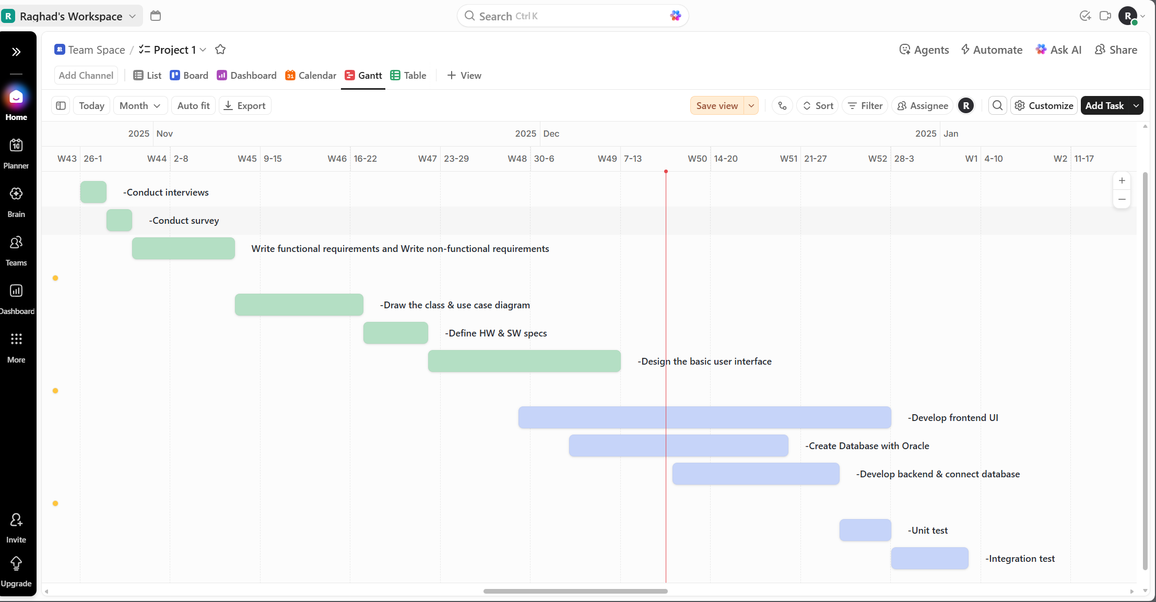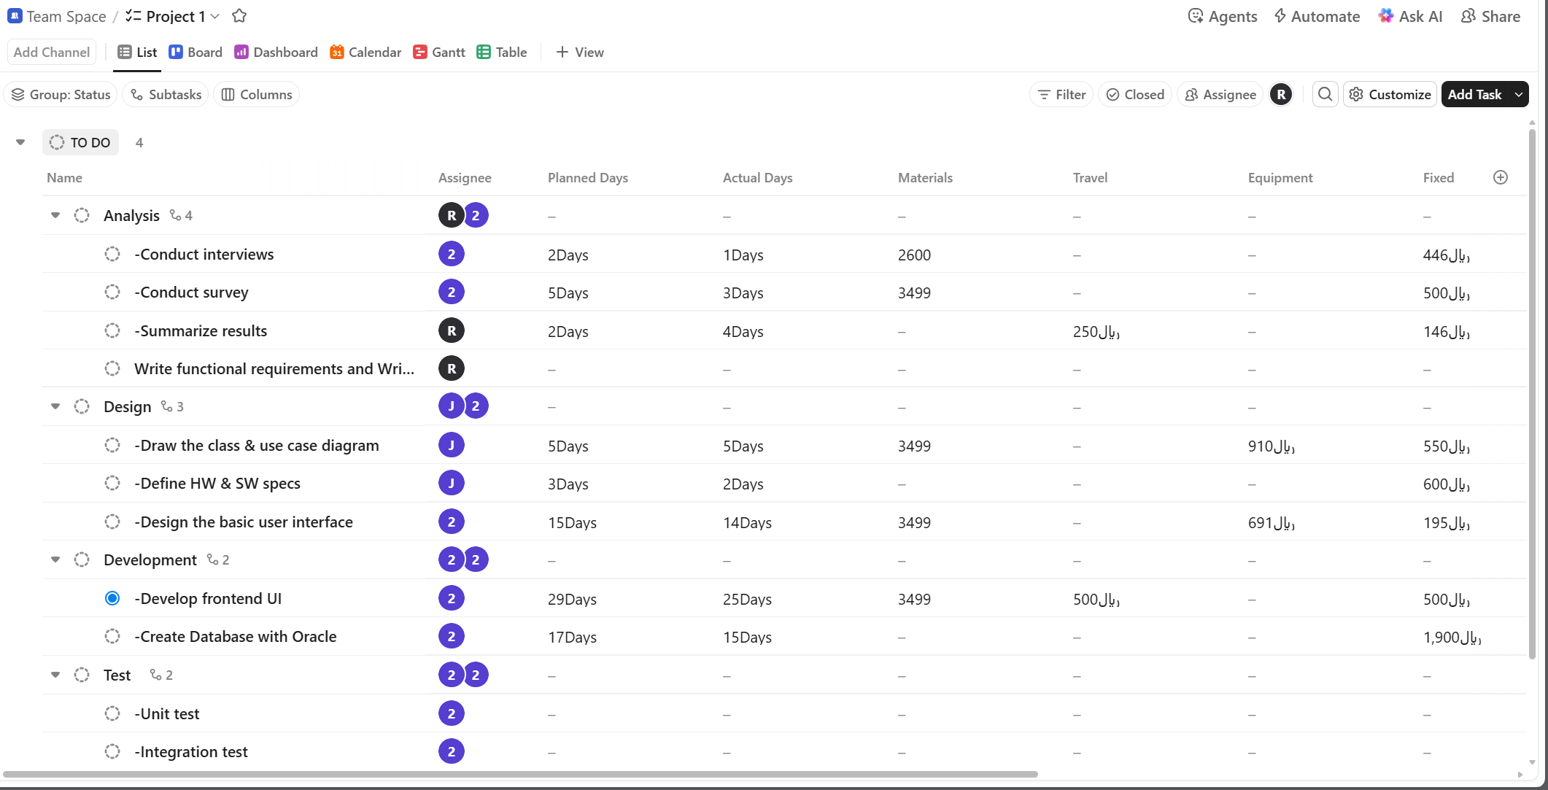

7. Project Budget

7.1. Budget Details
Analysis Tasks: Conduct interviews, Conduct survey, Write functional requirements, Write non-functional requirements. Materials: laptop.travel: Traveling from Jeddah to Riyadh for interview ,two nights hotel stay. Fixed: internet.

Design Tasks: Draw the class & use case diagram, Define HW & SW specs, Design the basic user interface. Materials: Laptop, Mouse ,keyboard, Monitor. Equipment: printer. Fix: internet.

Development Tasks: Set up project environment, develop frontend UI, create database with Oracle, Develop backend & connect database. Materials: laptop. travel: Traveling from Jeddah to Riyadh for training on oracle, 2weeks hotel stay.

Test tasks: Unit test, Integration test. Materials: USB Flash Drive

Table 7: Project Budget Details
This table presents the employees’ wages for the duration of this task, calculated by multiplying each employee’s daily wage by the number of days worked, along with the required equipment and other expenses such as travel and monthly subscriptions.
Task | Labor Costs | Material Costs | Other Costs | Budget | Actual
Conduct interviews  Conduct survey | 860rs | 3,449sr | 2,576sr | 6,995sr | 7150sr
Write functional requirements and non-functional requirements | 2150rs | 3,499sr | 500sr | 5,074sr | 4,644sr
Draw the class & use case diagram,  Define HW & SW specs | 3495rs | 4,646sr | 2,156sr | 8,200sr | 8433sr
Design the basic user interface. | 5250rs | 4,646r | 1,289sr | 17.036sr | 16,686sr
develop frontend UI, create database with Oracle | 25300rs | 3,499sr | 4,884sr | 33683sr | 31483sr
Develop backend & connect database | 7150rs | 3,542sr | 699sr | 11,392sr | 9.742sr
Unit test | 2200rs | 33sr | ---- | 2.233sr | 2,233sr
Integration test | 2200rs | 33sr | ---- | 3.333sr | 2,233sr

7.2. Task Cost Breakdown
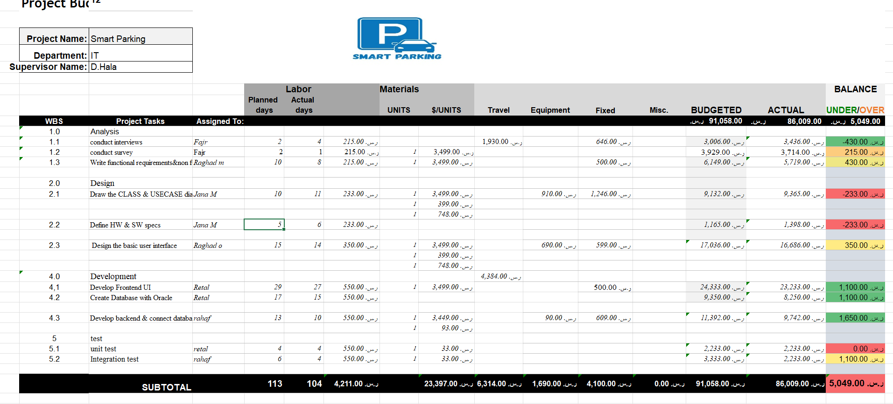

7.2.1. total project budget
This Excel presents the total project budget by comparing the planned costs with the actual expenses. It shows that the overall planned budget was 91,058 SAR, while the actual cost reached 86,009 SAR, resulting in a positive variance of 5,049 SAR in favor of the project."

8.Quality management plan

8.1 Quality plan
Table 8:Quality Measurements
This table outlines the quality standards the system must meet, such as response speed, data accuracy, and system availability, to ensure high performance and user satisfaction.
Quality Measurements
Description | Measurement
The system must update the parking list and display new availability within 3 seconds after receiving server data | Update Time
The system must respond to user actions (e.g., opening screens, pressing buttons) within 2 seconds or less. | Response Time
The accuracy of displaying the parking status (available/reserved) must be 90% or higher. | Parking Availability Accuracy
The system must maintain 95% uptime availability per day, excluding scheduled maintenance. | System Reliability
The final release must not contain more than 5 critical or major defects, as identified in the testing phase. | Error Rate
The accuracy of detecting the user’s and parking location must be within the range of 5–10 meters. | Location Detection Accuracy

8.2.1. Quality Control
Table 9:Quality Control
This table explains the roles and responsibilities of team members in monitoring quality, ensuring that each deliverable meets the required standards through review and verification."

Key Responsibilities
Role | Team Members | Detailed Responsibilities | How Quality is Achieved
Project Manager | retal | - Managing the project timeline and assigning weekly tasks.  - Updating the project plan and reviewing weekly progress.  - Coordinating communication among team members. | - Using a Quality Checklist to review deliverables.  - Ensuring all tasks follow the Project Plan Folder.  - Conducting weekly review meetings.
System Analysts | Fajr, Raghad Mansour | - Gathering and analyzing requirements.  - Preparing UML diagrams and system flow.  - Creating the complete system plan for developers. | - Using the Requirements Verification Checklist.  - Following UML standards for diagrams.  - Reviewing requirements accuracy before development.
Designers | Raghad Obaed, Jana | - Designing UI screens and components.  - Preparing wireframes and prototypes.  - Ensuring style consistency using the design guideline. | - Using the UI Guideline Folder.  - Submitting designs through the UI Review Form.  - Checking visual consistency and accessibility.
Developers | Retal, Rahaf | - Implement frontend & backend.  - Connect modules & build features.  - Fix bugs reported by testers.  - Unit & Integration Testing.  - Follow Coding Guidelines. | - Unit & Integration Testing to ensure modules work.  - Follow Coding Guidelines.  - Fix defects promptly.
Testers | Retal, Rahaf | - Execute test cases.  - Report defects & verify fixes.  - Unit, Integration & System Testing.  - Ensure full system functionality. | - Complete test coverage with Test Cases.  - Verify fixes.  - Ensure system works end-to-end.

8.2.2. Quality Assurance Activities
- Reviewing system requirements to ensure clarity and alignment with user needs.
- Conducting code reviews to follow coding standards and prevent performance or security issues.
- Reviewing system and database design to ensure scalability and ease of maintenance.
- Performing unit and integration testing to verify correct system functionality.
- Reviewing the user interface to ensure usability and consistency.
- Conducting security checks to ensure proper authentication and access control.
- Tracking and resolving identified issues based on priority.

8.2.3. Quality Control Schedule

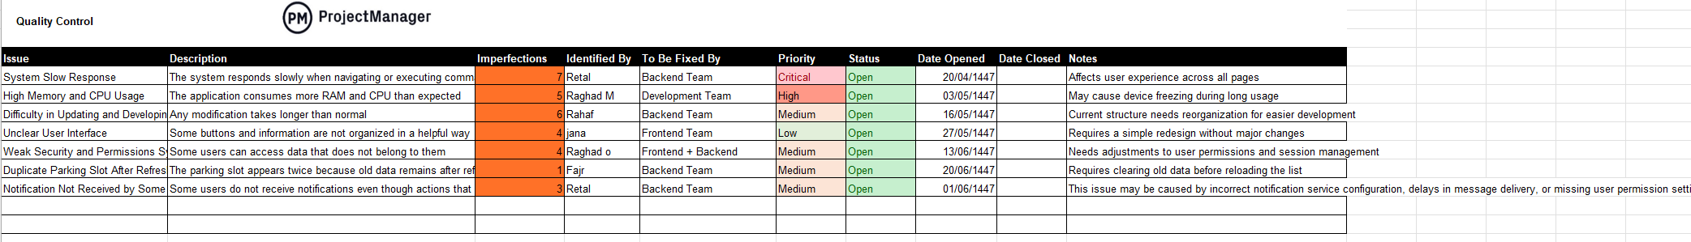

9. Risk Management Plan

9.1 Risk categories
Our project faces several technical risks, including application bugs, compatibility issues across different devices, and the need to expand the database while integrating cloud service subscriptions.
We also encounter some external challenges, such as dependence on external network providers, which may affect the accuracy or timeliness of the displayed parking information.
On the organizational level, we face issues related to increased support from the Parking Authority, where delays or inconsistencies in data updates may impact system performance.
Financially, we also face certain risks, including the increased cost of map services, which may affect the overall project budget.

9.2 Risk Register
Table 10:Risk Register: This table highlights the potential risks that may affect the project, describing their impact, risk level, response strategy, and the person responsible for handling each risk

ID | Catotegory | Description of Risk | Impact | Risk Response | Risk Level | Risk Owner
1 | Technical | Application bugs | Some app functions may stop working. | Test regularly and fix issues quickly. | Medium | Rahaf
2 | Technical | Compatibility issues | App may not work on some devices or OS versions. | Test on multiple devices and systems. | Medium | Raghad Obeid
3 | Technical | Expansion of the database and subscription to cloud services | Better performance and higher accuracy | Integrate the new technologies into the system | Medium | Retal,rahaf
4 | External | Dependence on external network providers | Delayed or inaccurate parking information for users. | Provide offline mode to display last saved data | Medium | Jana
5 | Financial | Increased map service costs | Budget overrun | Compare providers and choose lower-cost API plans | Low | Raghad
6 | Organizational | Increased support from the Parking Authority | More accurate and updated data | Strengthen communication and use improved data | Medium | Fajr

General conclusion
The Smart Parking System for the University of Jeddah – Khulais Campus demonstrates the effectiveness of using GPS-based technology to simplify and enhance the parking experience within the campus. Through this prototype, users can easily identify available parking spaces, while administrators are provided with a simple dashboard to maintain accurate parking availability.

This project serves as a foundational step toward building a fully integrated smart parking solution that can be expanded to other university branches in the future. Although the system is still in its initial phase, the results highlight significant potential to reduce congestion, save time, and improve overall campus mobility. With further refinement and added features in upcoming stages, the system can evolve into a comprehensive smart parking platform that supports the university’s vision for digital transformation

Appendix:
Note: Here, I will add some additional details that I did not include above, related to my project.

First: This section presents the vision and objectives of my project (University of Jeddah – Khulais)-

Vision and Goals
Vision:
To provide a smart and efficient parking solution for the University of Jeddah – Khulais Campus, aiming to reduce time wasted searching for parking and improve the experience for students and staff.
Goals:
• Enable students and staff to quickly find available parking spaces.
• Develop a working prototype (trial version) specifically for Khulais campus.
• Design a simple and user-friendly interface focused on user experience.
• Accurately display available parking spaces in real-time using GPS data.
• Test the system in a small-scale area to simulate real usage and demonstrate effectiveness.
• Support future scalability to add other campuses or new features.

Next, I will present a table of the phases, activities, and Deliverables of my project.

Note: I have added the tasks for my project on page 6 in the Scope table.

Table 11:Phases Table
Phase | Description | Sequence
Analysis | Studying the current parking challenges at the University of Jeddah – Khulais Campus and identifying user needs. | Phase 1
Requirements Gathering | Defining the functional and technical requirements for the GPS-based parking system. | Phase 2
System & App Design | Creating the system architecture, database structure, and user interface design for the prototype. | Phase 3
Development & Programming | Developing the prototype, integrating GPS data, and building the web/app interface. | Phase 4
Testing & Field Trial | Testing GPS accuracy, validating parking availability display, and fixing issues. | Phase 5

Activities Table:
The following table summarizes all project phases, tasks, descriptions, and their execution sequence for building the Smart Parking System prototype.
Sequence | Phase | Task | Description
1 | Requirements & Analysis | Conduct interviews, conduct survey, and summarize results | Collect information about parking issues and understand user needs in Khulais campus.
2 | Requirements & Analysis | Write functional and non-functional requirements | Document all system requirements including GPS mapping and parking display functions.
3 | System Design | Draw the class diagram and use case diagram | Create UML diagrams showing how the system works and how users interact with it.
4 | System Design | Define hardware and software specifications | Specify tools and technologies needed such as GPS API, database, and development environment.
5 | System Design | Design the basic user interface | Design UI screens for displaying parking spaces on the map.
6 | Development Preparation | Set up project environment | Prepare project files, structure, and required libraries.
7 | Development | Develop frontend UI | Develop the user interface for interactive parking display.
8 | Development | Create database | Build a database to store parking status (available / occupied).
9 | Development | Develop backend and connect database | Connect frontend to the database to update parking data in real time.
10 | Testing | Unit Test | Test each component separately to ensure correct behavior.
11 | Testing | Integration Test | Test the complete system after connecting all components.
Table 12: Activities

Deliverables Table:
Here, we present the project structure, which includes:
Third:

Note | Description | Title
Part of the main documentation. | A detailed report explaining how GPS data is used to display available parking spaces within the Khulais campus. | GPS-Based Parking Availability Report
Based on the testing phase. | An analysis of parking usage, occupied vs. available spaces, and peak-time observations. | Parking Utilization & Occupancy Report
Includes improvement notes. | An assessment of system responsiveness, map accuracy, and limitations found during testing. | System Performance & Evaluation Report
Supports future development phases. | Documentation of GPS data integration and a roadmap for expanding the system to other university branches. | GPS Data Integration & Future Expansion Plan

Here, we present the project structure, which includes: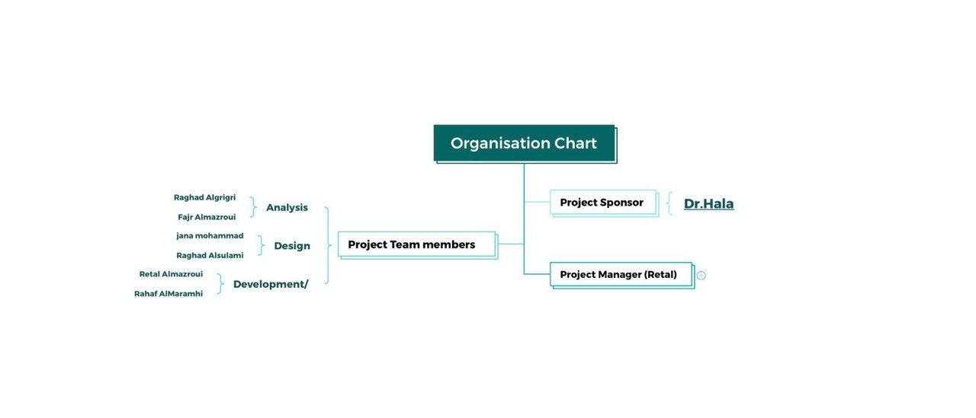

References

Source of salaries:
Designer
Programmer
analyst
Sources of equipment:
laptop
USB Flash Drive
Internet
Monitor
keyboard
Mouse
Travel References:
Tickets 1: Saudi Airlines
Hotel 1: Booking
Tickets 2 : Saudi Airlines
Hotel 2 : Booking

